IT 497 Lab 7

library(tidyverse)

## -- Attaching packages -------------------------------------------------------------------- tidyverse 1.3.0 --

## v ggplot2 3.3.2 v purrr 0.3.4  
## v tibble 3.0.3 v dplyr 1.0.2  
## v tidyr 1.1.2 v stringr 1.4.0  
## v readr 1.3.1 v forcats 0.5.0

## -- Conflicts ----------------------------------------------------------------------- tidyverse_conflicts() --  
## x dplyr::filter() masks stats::filter()  
## x dplyr::lag() masks stats::lag()

library(dplyr)

set.seed(955)  
# Make some noisily increasing data  
dat <- data.frame(cond = rep(c("A", "B"), each=10),  
xvar = 1:20 + rnorm(20,sd=3),  
yvar = 1:20 + rnorm(20,sd=3))  
head(dat)

## cond xvar yvar  
## 1 A -4.252354 3.473157275  
## 2 A 1.702318 0.005939612  
## 3 A 4.323054 -0.094252427  
## 4 A 1.780628 2.072808278  
## 5 A 11.537348 1.215440358  
## 6 A 6.672130 3.608111411

# Question 1  
ggplot(dat, aes(x=xvar, y=yvar)) +  
geom_point(shape=8, size=2) + # use shape 8  
geom_smooth(method=lm, color="red", # Add red linear regression line  
se=FALSE) # Don't add shaded confidence region

## `geom_smooth()` using formula 'y ~ x'

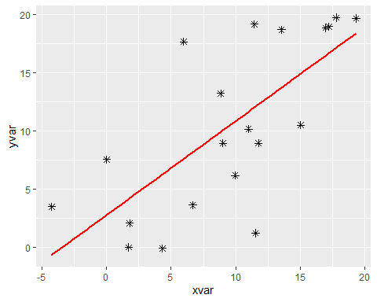

# Question 2  
ggplot(dat, aes(x=xvar, y=yvar, color=cond)) + geom_point(size=2) +  
geom_smooth(method=lm)

## `geom_smooth()` using formula 'y ~ x'

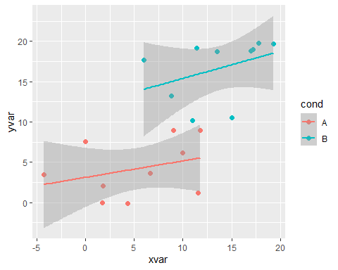

# Question 3  
df <- data.frame(dose=c("D0.5", "D1", "D2"),  
len=c(4.2, 10, 29.5))  
head(df)

## dose len  
## 1 D0.5 4.2  
## 2 D1 10.0  
## 3 D2 29.5

library(ggthemes)

## Warning: package 'ggthemes' was built under R version 4.0.3

p<-ggplot(data=df, aes(x=dose, y=len)) +  
geom_bar(stat="identity")+ coord_flip()+ theme_economist() +  
 ggtitle("Vitamin C's impact on tooth growth in Guinea pigs")  
p

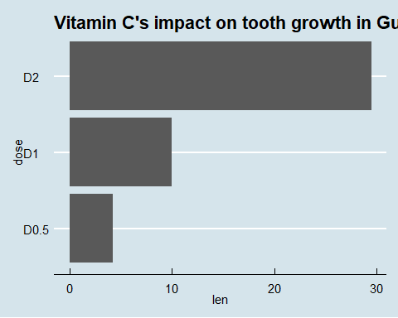

# Question 4  
#Data for question 4.  
set.seed(1234)  
dat <- data.frame(cond = factor(rep(c("A","B"), each=200)),  
rating = c(rnorm(200),rnorm(200, mean=.8)))  
# View first few rows  
head(dat)

## cond rating  
## 1 A -1.2070657  
## 2 A 0.2774292  
## 3 A 1.0844412  
## 4 A -2.3456977  
## 5 A 0.4291247  
## 6 A 0.5060559

ggplot(dat, aes(x=cond, y=rating, fill= cond)) + geom_boxplot() + theme_stata() + theme(legend.position ="bottom") + scale_fill_manual(breaks = c("A", "B"), values = c('darkblue', 'darkred'))

